North Cape School is hosting a
Family Connection Evening
For All North Cape Parents

“The Good, The Bad and the Digital: The Effects of Social Media on Children”

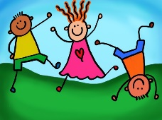
Join us on Wednesday, March 6th
at 5:30-7:00 in the library

Nationally Recognized Speaker:
Michael McGowan
Mr. McGowan has worked nationally with thousands of students/teachers, the NFL, MLB and companies over the last 20 years. Mr. McGowan’s presentations are entertaining and practical.
Please join us for an informational, important and entertaining evening. We will serving Taco’s at 5:30PM and offering child care but you must RSVP with number attending and if you need child care by March 1st to: kwitzeling@northcape.12.wi.us

